B520 – How to Resend Missing Reservations

Retransmit any missing reservations that were not delivered to Budget (or its licensees). To do that, the user would have to find out the sequence # of the missing reservations for the company through the GIS Maestro Reservation Error report.

Mandatory Fields:

Command: XMT
Routing Code: 5-digit code of designated company
Date: Date of missing reservation
Starting Sequence: Starting sequence # of the reservation
Ending Sequence: Ending sequence # of the reservation
Alt. Dest. Routing Code:

Note: Only reservations for the current and previous 4 days can be pulled.

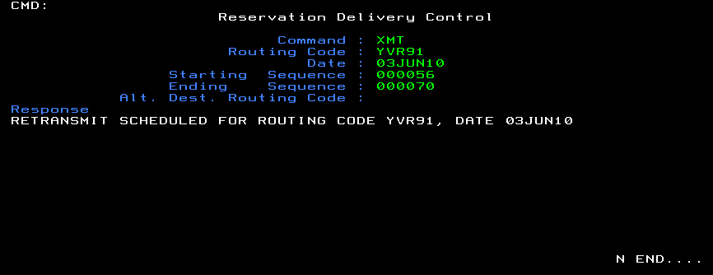

Routing Code:

Company | Routing Code | Company ID
Budget BC | YVR91 | 7425
Phelps | YVRRQ | 7409
Budget Victoria | YYJRC | 7440
Geordy | YXXRC | 7412
Devon | YCDRC | 8410

Tip:

- How do we know what the available commands/actions are for a screen?

By entering a valid value in one mandatory field and leave the other required ones empty, Maestro will display a list of available actions to choose from. (E.g. Enter routing code and click enter will cause Maestro to display an error message and show all available commands.)

Other available commands in B520 are:
INQ – Check to see whether there are any reservations to pull
PUL – Seldom used (even by corporate)
LOG
LST – List reservations by sequence #
STA – Displays res delivery information for a fleet owner

- Getting the error message “ENDING SEQ NUMBER EXCEEDS LAST SEQ NUMBER PULLED. ISSUE PUL COMMAND” while attempting to resend reservations.

By issuing the INQ command, you will see the last sequence # that was sent. Therefore getting the error message above indicates that you are attempting to resend a sequence number that does not even exist.

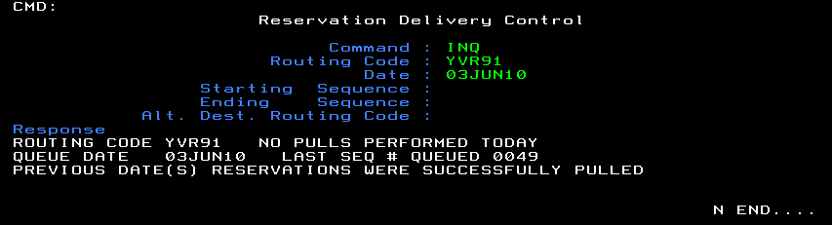

- Instead of copying the reservation’s confirmation # from maestro and check its status in GIS, you can check the status of reservations directly on Maestro if you know their sequence #s.

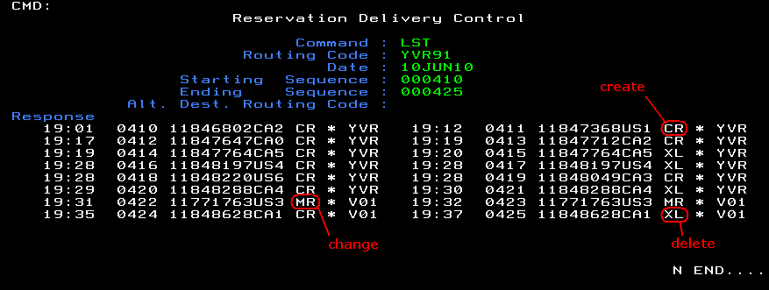

The returned results show (from left to right) the time the reservation was made, the seq #, the confirmation #, the status of the reservation and the pickup location of the reservation.

